REPORT TO: POLICY AND RESOURCES - 27 JUNE 2022

REPORT ON: PERIOD PRODUCTS (FREE PROVISION) (SCOTLAND) ACT 2021

REPORT BY: EXECUTIVE DIRECTOR OF CHILDREN & FAMILIES SERVICE AND HEAD OF CHIEF EXECUTIVE SERVICES

REPORT NO: 159-2022

1.0 PURPOSE OF REPORT

To update Committee on the requirements placed on Dundee City Council by the Scottish Government’s Period Products (Free Provision) (Scotland) Act 2021 and how Dundee City Council will implement these.

2.0 RECOMMENDATIONS

2.1 It is recommended that Committee:

(i) note and approve the contents of this report, including the feedback from consultations; and

(ii) remit the Head of Chief Executive Service and the Executive Director Children and Families Service to implement the proposals set out in section 7.0 of the report.

3.0 FINANCIAL IMPLICATIONS

3.1 The funding provided by the Scottish Government for this provision for 2022/23 is £144,000. The total expenditure for 2021/22 was £81,700.

3.2 In April 2021, COSLA Leaders agreed to an approach to funding including an evaluation and data collection framework between 2021-22 and 2025-26. This framework will inform the baselining of the funding from 2026-27. The framework is intended to capture changes in demand and uptake across four financial years, in order to ascertain what the appropriate level of funding will be as the duties under the Period Products (Free Provision) (Scotland) Act come into force.

3.3 Evaluation will be undertaken by the Scottish Government following a monitoring return to understand if any uplift to funding is required. Any uplift will be applied as in-year adjustments to 2022/23 funding allocations with the baseline adjusted rate applied to full year allocations for 2023/24-2025/26.

4.0 BACKGROUND

4.1 Period Products (Free Provision) (Scotland) Act 2021 will come fully into force on 15 August 2022, through laying relevant commencement regulations. From this date local authorities will have a legal duty to make period products available for free for anyone who needs them, and in their role as education authorities, make period products available for free in schools. The Period Products in Schools Regulations 2020 will be repealed on this date as the provisions in the Act supersede these regulations.

4.2 There are two sections to the Act and the Council is required to set out prior to its implementation how the council shall fulfil the duties placed on them:

- Section 1 of the Act places a duty on Local Authorities to make period products obtainable free of charge for anyone who needs to use them. (Community provision).

- Section 2 of the Act places a duty on education providers to make period products obtainable free of charge on their premises for pupils and students during term time. (Education provision).

4.3 The key requirements of Section 1 for Community provision are as follows:

- Make products available, easily accessible and in a dignified way, offering a choice of products (choice need not be given in each location).

- Flexibility is given to local authorities in how they give access and on what they provide in each location.

- Information/communication on where products are available should contribute to the easy access.

- Needs should be met outside normal working hours/weekends.

- Specific consideration should be given to those with barriers to accessing products, direct provision can be given to these groups.

- Access should consider the privacy of those accessing (discreet bags for example).

- Local authorities to ensure that free period products are obtainable by another person on behalf of the person who needs the products.

- Different arrangements may be put in place to access free reusable products which may require individuals to ask for these products, given the significantly increased cost over single use products.

4.4 The key requirements of Section 2 for Education Provision are as follows:

- Establish and maintain arrangements for period products to be obtainable free of charge during term time on their premises, including in particular in every building normally used by pupils and students.

- Only required to be in one location within a building, education providers have the flexibility to decide (subject to consultation) which products should be made obtainable and in what way and in which locations in each such building, as long as free products are available in at least one location.

- There is no requirement on education providers to make period products obtainable for use out with term time. Out with term time, pupils and students will be able to access free period products under the arrangements put in place by local authorities under section 1.

4.5 Further and Higher educational establishments across the City also receive funding from the Scottish Government and have associated procedures in place to provide access to products within their premises and residential accommodation.

5.0 CURRENT PROVISION

5.1 Access to free sanitary products has been in place in schools since October 2018 and in public buildings since October 2019. In addition to schools, 44 public buildings in Dundee currently provide access to free products including all libraries, community centres, food project/larders, etc. A number of these premises ensure access is available out with normal opening hours including evenings and weekends. Appendix 3 maps out where provision is available.

5.2 Direct provision is also currently made to a number of targeted groups who may have additional barriers to accessing products including young children’s residential homes, young carers, from a number of NHS provider settings and other identified minority groups.

5.3 In response to the Covid-19 pandemic when schools and public buildings closed, a home delivery service was established which allows residents of the city to order products and have them delivered directly to their homes. The online ordering service has continued to be offered and is currently delivered by partner organisation Hey Girls. This offers the opportunity to order a bulk supply of products including a wide choice of reusables to be delivered direct to homes.

5.4 A dedicated page on our website outlines the full provision available including a link to the online ordering form for home delivery and a dedicated email address for any queries around access to products. The webpage also provides information and links to the recently developed PickUpMyPeriod App which shows the publicly accessible locations across the City and associated information to enable access to products.

5.5 The schools and wider community provision are currently delivered in partnership with Tayside Contracts. We have worked in partnership with Tayside Procurement Consortium and created a delivery model with Tayside Contract Services, in partnership with Angus Council and Perth and Kinross Council. Tayside Contracts, have taken on the role, in most settings, of ordering, providing and replenishing period products in identified places in schools and public buildings, including toilets. The partnership with Tayside Contracts enables us to provide better value for money, increased product range and an efficient logistical model.

5.6 It is estimated that there is 44,924 people entitled to access free products in the City. A recent return to the Scottish Government shows that during 2021/22 there were a total of 182,919 individual products (178,465 single use and 4,454 reusable) that have been made available via schools, public buildings and the home delivery service throughout Dundee. The products range in cost per unit from £0.77 for singles use to £3.30 for reusable products.

6.0 CONSULTATION

6.1 The Act requires each local authority to undertake consultations with children and young people and the wider public and use this feedback to publish a statement of intent. To ensure that the arrangements we put in place meet people’s needs we were required to consult with individuals who may either:

(a) need to use free products currently
(b) need to use products in the future, or
(c) need to collect products on behalf of someone who needs to use product

6.2 Consultation took place across Dundee schools and the wider community between November 2021 and February 2022. The full consultation details are included in Appendices 1 and 2. Questions asked related to:

- the current provision available including; where and what products had been accessed, how this experience had been in terms of feeling comfortable accessing products.

- future provision focused on where people would like to access products and the preferences on choice of products given. Also covered was whether people felt that they had particular personal circumstances which would affect the way in which products were accessed and suggestions around what could be done to help overcome these barriers to access.

Schools’ Consultation Feedback (Appendix 1)

6.3 Dundee’s secondary schools distributed an online survey and received 629 responses. In primary schools, focus groups were conducted in all 8 clusters with a total of 85 participants. The vast majority of pupils were aware of the service and were satisfied with the provision. Key feedback was:

- General awareness of the free provision and locations within schools is good, but around half of pupils do not know how to access products during weekends and holidays.

- Single-use pads were accessed the most (88%) and are also the most requested product for future provision.

- A third of pupils have not yet accessed the provision. When they do access products, most collect for immediate use only and under a third collect for both immediate and long-term use.

- Embarrassment is the biggest barrier to accessing products. This is in line with toilets being the most preferred location, and display stands the least.

- Reusables are used by few, but requested by around a third of pupils.

Community Consultation Feedback (Appendix 2)
]
6.4 The online survey was available via the council’s and partners’ websites and a total of 152 responses were gathered from across the city with further input from targeted groups. A wide range of age groups responded, the majority of people were accessing products for themselves however a number were accessing for family members or for those who they had caring responsibilities. It was encouraging to note that the vast majority of those who had used the service had felt comfortable doing so and welcomed the choice of products made available. Key feedback is as follows:

- The most common method of currently accessing products is via online ordering for home delivery (61.8%), followed by access via school/university. Online ordering is stated as being the preferred way of access for future provision (79.6%), followed by educational establishments (59.2%).

- Those who had not accessed the service (61.8%) stated that this was either due to a lack of awareness of the provision available and/or that they didn’t think they were eligible.

- Single use products have been accessed the most (68.4%). In line with this, single-use products are requested the most for future provision, followed by specific reusable products.

- The majority of those who had accessed products stated that they felt comfortable and dignified using the current service.

- Toilets are the preferred location of products within premises and asking at reception areas the least preferred option.

- Not knowing where to go was identified as the biggest barrier, followed by being unsure of eligibility, and embarrassment.

- Those with health issues stated that an online method of ordering was preferred.

7.0 PROPOSED FUTURE PROVISION

Access and Availability of Products

7.1 The current provision across our schools and community premises set out in para 5.1 will be maintained and uptake monitored as footfall in buildings is increasing due to Covid restrictions relaxing.

7.2 There will be engagement with premises to ensure they are fully aware of the requirements of Act and to ensure suitable dignified access is in place including where possible in gender neutral toilets. Resources required to signpost and/or aid a dignified method of ace will also be reviewed.

7.3 The website and Pick Up My Period app will be updated and refreshed to ensure that anyone wishing to access products know where, when and how to do this, including more promotion of our home delivery service.

7.4 The home delivery service will continue to be provided as it was highlighted as the most popular way to access products. It is likely that more providers move into this market, so we will evaluate uptake, performance and costs to ensure we have the best option to meet our needs and deliver best value.

7.5 Schools also plan to include work around period poverty within Cost of the School Day Action Plans, expand availability of products within schools, including disabled toilets, and to identify a suitable, dignified way for those who menstruate to pick up bulk products, particularly before school holidays.

Awareness Raising and Communications

7.6 It is clear from the consultation, that more awareness raising of this entitlement and provision of products is needed across the city. This has also been raised by neighbouring councils (Angus and Perth & Kinross) as well as the FE/HE sector, in particular Dundee & Angus College and Perth UHI. It is therefore proposed that we all collaborate on this by creating a post to be hosted by Dundee & Angus College and developing shared digital resources. This would be for a 2 year period and our contribution would be up to £10,000 per annum.

7.7 Following the creation of the above post, a communication strategy is to be developed to raise awareness of availability of products including, social media and advertising campaigns, promotional material for display in premises, engagement with other services and partners to raise awareness in communities and more directly to targeted groups. Other key areas we would wish to cover within this work are:

- Reduce the stigma and normalise menstruation, particularly for children and young people. This in turn will reduce embarrassment, which has been identified by children and young people as the leading barrier, suggestions include empowering them by creating peer led groups.

- Raise awareness and knowledge of reusables, including the environmental impacts.

- Promote the free provision to know where products are available, including for children and young people during weekends and holidays. Signposting to community provision via the Pick Up My Period app and through the home delivery service.

Uptake and Monitoring

7.8 Annual returns to the Scottish Government are required to be completed detailing numbers and types of products as well as expenditure incurred. Officers within Chief Executive Services will gather this data and monitor expenditure going forward.

7.9 The availability and uptake across premises will be monitored to identify fluctuations in demand, product types required and as well as assessing and addressing any identified gaps in provision. As more data becomes available we will also undertake targeted locality communications as needed.

8.0 POLICY IMPLICATIONS

8.1 This Report has been screened for any implications in respect of sustainability, strategic environment assessment, anti-poverty, equality impact assessment and risk management.

IIA to be completed

9.0 CONSULTATION

9.1 The Council Management Team have been consulted in the preparation of this report.

10.0 BACKGROUND PAPERS

None.

AUDREY MAY | DATE: 17 MAY 2022
EXECUTIVE DIRECTOR OF CHILDREN & FAMILIES SERVICE

ANDREA CALDER | DATE: 17 MAY 2022
HEAD OF CHIEF EXECUTIVE'S SERVICES

APPENDIX 1

Dundee City Council

Dundee City Council - Period Products Provision
Schools Consultation

February 2022

Table of Contents
1. Background 9
2. Recommendations for Consideration 9
3. Secondary Schools 9
3.1 Summary 9
3.2 Current Provision 9
3.3 Use of Products 10
3.4 Future Provision 13
3.5 School Summaries 15
3.5.1 Baldragon Academy 15
3.5.2 Braeview Academy 16
3.5.3 Craigie High School 16
3.5.4 Grove Academy 17
3.5.5 Harris Academy 17
3.5.6 Morgan Academy 18
3.5.7 St John’s RC High 18
3.5.8 St Paul’s RC Academy 18
3.5.9 Off Site Education Service (Rockwell) 19
4. Primary Schools 19
4.1 Summary 19
4.2 Current Provision 19
4.3 Use of Products 20
4.4 Future Provision 20
5.Appendix (Secondary Schools Survey) 21

1. Background

To prepare for the implementation of the Period Products (Free Provision) (Scotland) Act 2021, and inform the development of the service, a survey was conducted among secondary school pupils and focus groups were held in primary schools across the city. The following report outlines the results.

2. Recommendations for Consideration

- Provide a range of sizes to meet individual preferences and needs, particularly single-use pads.

- Reduce stigma and normalise menstruation to reduce embarrassment as the leading barrier, suggestions include posters and peer led groups.

- Raise awareness and knowledge of reusables, and increase availability to meet the demand.

- Promote the free provision to ensure students know where products are available and how much they can take. This includes how to access products during weekends and holidays, for example by offering bulk packs and signposting to community provision through the Pick Up My Period app.

- Expand offerings to all or more toilets in the building, including disabled toilets, and identify a suitable, dignified way for males to pick up products.

3. Secondary Schools

There were 629 respondents from secondary schools. The following section provides a summary of the key findings.

3.1 Summary

- General awareness of the free provision and locations within schools is good, but around half of pupils do not know how to access products during weekends and holidays.

- Single-use pads were accessed the most and are also the most requested product for future provision.

- A third of pupils have not yet accessed the provision. When they do access products, most collect for immediate use only and under a third collect for both immediate and long-term use.

- Embarrassment is the biggest barrier (55%). This is in line with toilets being the most preferred location, and display stands the least.

- Reusables are used by few, but requested by around a third of students.

- Suggestions for future provision include: normalising menstruation to reduce stigma, more awareness of free provision and locations, products in all/more toilets, bulk pick up packs and a variety of products/sizes for different flows and needs.

3.2 Current Provision

The majority of pupils who took part in the consultation attend Braeview Academy and Craigie High School, while others attend St Paul’s RC Academy, Grove Academy, St John’s RC High School, Morgan Academy, Baldragon Academy, Harris Academy and offsite education (Rockwell).

Secondary School | Respondents
Braeview Academy | 28.3%
Craigie High School | 26.4%
St Paul's RC Academy | 17.5%
St John's RC High School | 8.7%
Morgan Academy | 8.1%
No response | 5.2%
Grove Academy | 3.0%
Baldragon Academy | 1.6%
Harris Academy | 0.8%
Off-site Education Service (Rockwell) | 0.3%
Table 1: School Response

Figure 1: School Experience: Awareness and Satisfaction
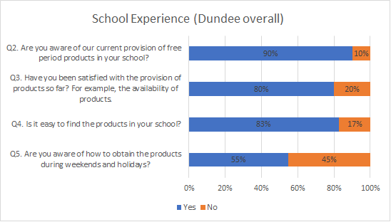

Awareness and satisfaction of the provision in Dundee overall is good, and the majority of pupils find it easy to locate the products. However, around half of all students do not know how to obtain products during weekends and holidays.

3.3 Use of Products

Single-use pads are used most by pupils, followed by single-use tampons. Reusable pads are rarely used, and a quarter of pupils have not yet accessed the products. Respondents that answered ‘Other’ mentioned period pants.

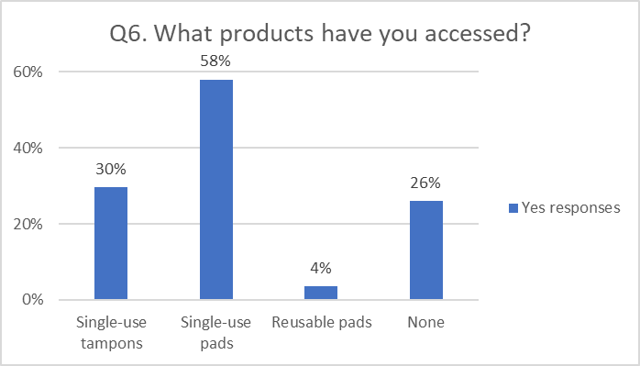
Figure 2: Products accessed

The majority of pupils only collect for immediate use. Students from all schools indicated collecting both, but to a lower extent, with bulk being collected the least.

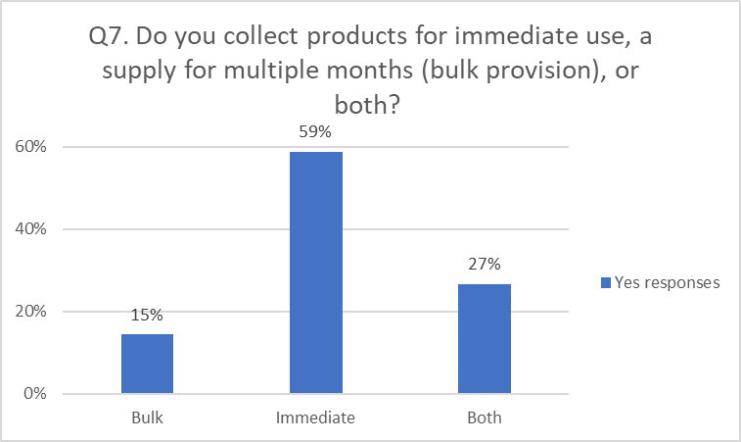
Figure 3: Collection of products

Overall, most felt fairly and very comfortable, with 16% of Dundee pupils indicating they do not feel comfortable or dignified. Notably, the majority of St Paul’s pupils feel very comfortable (61%), which is particularly higher compared to other schools.

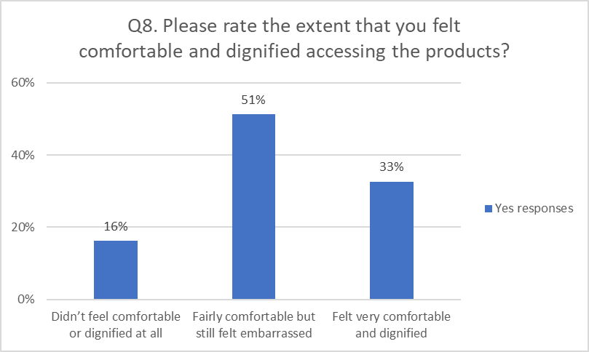
Figure 4: Feeling comfortable and dignified access of products

Embarrassment is identified as the leading barrier to accessing products, followed by not knowing where to go and not being sure how much they can take. Language barrier is perceived as a barrier by few pupils.

Students that responded ‘other’ mentioned the following issues: products being cheap or bad quality, too little choice for varying needs and flows, a supply at home, identifying as male, not available in all bathrooms or not stocked up enough, and sanitary concerns following misuse of products.

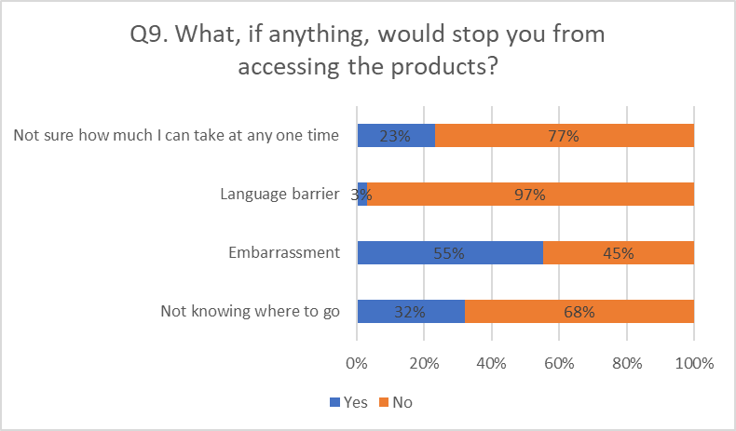
Figure 5: Barriers to accessing products

3.4 Future Provision

Pads and bulk provision of pads are the most requested items, followed by tampons and bulk tampons. Reusables are less popular, with a third of pupils requesting them.

Pupils that responded ‘other’ mentioned the following: sizes for different flows, tampons with applicators, spare underwear/clothes, pain relief (hot water bottle, paracetamol), and hand sanitizer.

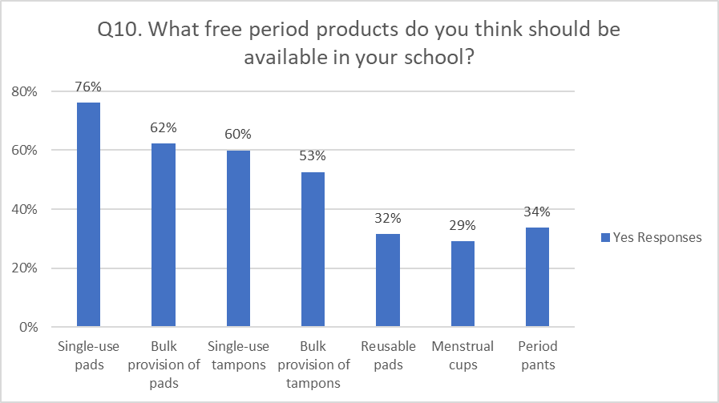
Figure 6: Product Provision

Pupils are happy to see products in toilets, and the majority disagree with visible places such as reception areas or a display stand. Students that responded ‘other’ mentioned the following locations: toilet stalls, discreet cupboard, guidance offices, designated teachers.

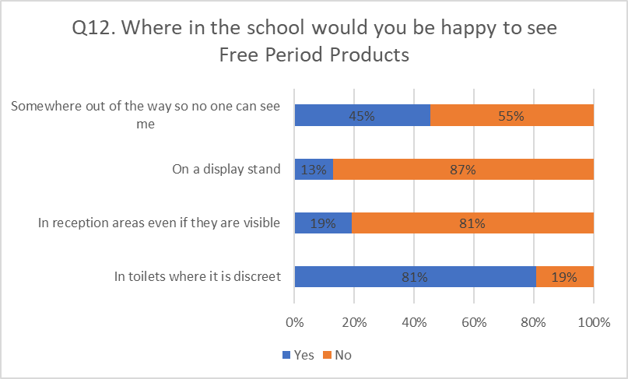
Figure 7: Location of free period products

Always was requested the most (56%), followed by Tampax (28%), Bodyform (13%) and Lillets (3%). Other brands that were mentioned are: Cheeky Wipes, Sana, The Eco Woman, Mobodi, Kotex, TOTM, Mooncup, Rael, Glad Rags, and Tomboy.

Suggestions for improving the service include: more choice of sizes, products in disabled and male, and all female toilets, more awareness/normality of periods as natural to reduce stigma, more awareness of free provision and locations (both within and outside school), different way of dispensing to avoid vandalism/misuse and bulk pick up packs.

3.5 School Summaries

The following section provides summaries for each of the secondary schools who participated in the survey.

3.5.1 Baldragon Academy

In total, 10 pupils from Baldragon Academy responded to the survey.

Current Provision

A third are not aware of the provision of period products, and half are not satisfied with the service. Over half of the pupils do not find it easy to locate the products in school, and the majority do not know how to obtain the products during weekends and holidays. Most of the above findings are lower compared to all other Dundee schools.

Use of Products

The products most used by pupils from Baldragon are single-use pads (60%), with a third not yet having accessed any products. Similar trends are found in other schools.

The majority of students collect products for immediate use, and a couple for both immediate and bulk use. According to students, most who have used the service find it fairly or very comfortable to use, however a third do not find it comfortable and dignified to access which is higher than most other schools.

In terms of barriers, the biggest factor for Baldragon students is not knowing where to go (80%), followed by not knowing how much to take (60%), and embarrassment (50%). This deviates from other schools where embarrassment is the most influential factor.

Future Provision

For future provision of products, students requested single-use pads and tampons the most, followed by bulk offering of these items. Reusable cups, pants and pads are less desired, however Baldragon students requested these products more than their peers in other schools.

In regard to the location of products within the school, all students would like to see the items in toilets where it is discreet (including male/female and disabled toilets) or alternatively somewhere out of the way for discreet collection. Visible locations were less desirable, as in line with other schools, but Baldragon students were more open to the idea than their peers.

One student provided a suggestion for future provision, which was to increase awareness of the service.

3.5.2 Braeview Academy

In total, 178 pupils from Braeview Academy completed the survey, which is the highest response across Dundee.

Current Provision

Almost all students were aware of the provision, with 86% being satisfied with the service. The majority of pupils report the products are easy to find in the school (90%), with fewer knowing where to obtain the products during weekends and holidays (70%). This trend is observed across other schools.

Use of Products

The products used most by pupils are single-use pads. Reusables are accessed by few, and out of the respondents, 24% report they have not used the provision so far. These findings are similar to other schools.

The majority of students collect products for immediate use, with a third using the service for both bulk and immediate purposes. Just over half of respondents find the service fairly comfortable to use, with 13% reporting they do not find it comfortable or dignified. A third indicate they find it very comfortable, which is among the highest ratings in Dundee.

Similar to other schools, embarrassment was identified as the biggest barrier for students. Pupils also mentioned cleanliness issues where products have been touched by others, lack of variety of sizes to meet their needs, and products being available only in selected toilets.

Future Provision

For future provision of products, students would like to see single-use pads most, also available as bulk supply. Among all schools, pupils from Braeview requested tampons the least (50%). Reusables such as pants, pads and cups are requested by around a third of pupils, as in line with other schools.

When asked about suitable locations for products within the school, toilets (including male/female and disables toilets) are the preferred location, followed by somewhere out of the way for discreet collection. Visible locations are much less desirable, with few agreeing to a display stand or reception area. Similar trends are seen across all schools. Comments mentioned a hidden cupboard, in pupil support, and in the toilet cubicle.

Suggestions for future provision include having the products available in every bathroom, more pads, deterring vandalism/misuse of products, and more awareness and reducing stigma around periods through posters.

3.5.3 Craigie High School

In total, 165 pupils from Craigie High School responded to the survey.

Current Provision

The majority of students are aware of the free provision, with 67% being satisfied with the service, the latter being slightly lower than the Dundee average. Many find it easy to locate the products in school (70%), but over a third do not know how to obtain products during weekends and holidays.

Use of Products

When asked which products they had accessed so far, respondents reported using single-use pads the most (48%), with a third not having used the service yet. Very few students have used reusable products, which is observed across all schools in Dundee. When collecting products, half do so for immediate use, and around a quarter collect for both bulk and immediate use, and bulk supply, the latter being higher than other Dundee schools.

The majority of students report they feel fairly (56%) or very (23%) comfortable and dignified accessing the products, however 21% did not. In terms of perceived barriers, embarrassment is found most difficult (67%), followed by not knowing where to go and how much they can take. Similar trends are found across Dundee.

Future Provision

In terms of future provision, students would like to have access to single-use pads the most, including bulk provision, followed by tampons. Craigie students requested tampons less than their peers. The demand for reusables is lower, as in line with other schools.

In regard to the location of products within the school, the most popular option by far is in toilets (including male/female and disabled toilets), followed by somewhere out of the way for discreet collection. Students disagree with visible locations such as reception areas or a display stand. This trend is consistent among all schools.

Suggestions for future provision include providing a larger range of sizes to meet varying needs and flows, more awareness of the free service and locations, reducing stigma, and bulk pick up packs.

3.5.4 Grove Academy

In total, 19 pupils from Grove Academy responded to the survey.

Current Provision

The majority of students are aware of the free provision, with 69% being satisfied with the service, which is lower compared to the Dundee average. Many find it easy to locate the products in school, but only half are aware of how to obtain the products during weekends and holidays.

Use of Products

When asked which products they had accessed so far, respondents report using single-use pads the most (63%), followed by tampons (37%). Similar to other schools, very few have accessed reusable products, and a quarter have not used the free provision yet. When collecting products, 69% do so for immediate use, whereas 15% use the provision for both bulk and immediate use, the latter being lower compared to other schools.

The majority of students report they feel fairly (64%) or very (14%) comfortable and dignified accessing the products, the latter being lower than the Dundee average. Furthermore, 21% did not find the service comfortable to use. In terms of perceived barriers, embarrassment is found most difficult, as in line with other schools. Grove students feel more confident in knowing where to go and how much they are able to take compared to their peers across the city. Pupils that provided additional comments on this question mentioned boys being present when collecting, being a boy, and products only being available in specific bathrooms.

Future Provision

In terms of future provision, Grove students requested tampons and single-use pads the most, which deviates from pads receiving the most requests throughout Dundee. The demand is lower for reusables, as in line with other schools. That said, Grove has the highest demand for reusable pads and pants across Dundee.

In regard to the location of products within the school, the most popular option by far is in toilets (including male/female and disabled toilets), followed by somewhere out of the way for discreet collection. Students disagree with visible locations such as in reception areas or a display stand. This trend is consistent among all schools. A couple of pupils also mentioned the guidance offices as a suitable place.

Suggestions for improvement include providing products in every cubicle and the single male bathroom as well as disabled toilets.

3.5.5 Harris Academy

In total, 5 pupils from Harris Academy completed the survey. Due to the low statistical power, results should be generalised with caution. Alternatively, it may be worthwhile looking at findings from Dundee overall or another school with comparable demographics.

Current Provision

Almost all students were aware of the provision, and satisfied with the service. Just over half of pupils report the products are easy to find in the school, with none knowing how to obtain the products during weekends and holidays, which is lower compared to other schools.

Use of Products

The products used most by pupils are single-use pads and reusables are accessed by few. This trend is observed across Dundee. All respondents report having used the service, which suggests a higher uptake than all other school, though this may be due to the low sample size.

The majority of students collect products for immediate use, with one using the service for both bulk and immediate purposes. Just over half of respondents find the service fairly or very comfortable to use, with 2 pupils reporting they do not find it comfortable or dignified.

Similar to other schools, embarrassment was identified as one of the leading barriers for students. The majority of pupils from Harris also reported not knowing where to go as a barrier, which is higher than most other schools, though may be influenced by the sample size.

Future Provision

For future provision of products, students would like to see (bulk provision of) single-use pads and tampons. Reusables such as pants, pads and cups are less desired, as in line with other schools.

Toilets (including male/female and disables toilets) are the preferred location for products. Unlike most other schools, where students disagree with visible locations, pupils from Harris are more open to a display stand and reception area.

3.5.6 Morgan Academy

In total, 51 pupils from Morgan Academy responded to the survey.

Current Provision

The vast majority of students are aware of the free provision, and are more satisfied with the service than their peers across Dundee. Many find it easy to locate the products in school, but only a third are aware of how to obtain the products during weekends and holidays.

Use of Products

When asked which products they had accessed so far, respondents report using single-use pads the most (44%), followed by tampons (24%), with very few having accessed reusables. This trend is found in all schools. Morgan has the lowest self-reported uptake in Dundee, with 40% of pupils indicating they have not used the provision yet. When collecting products, the majority do so for immediate use, followed by both bulk and immediate, and bulk provision, as in line with other schools.

The majority of students report they feel fairly (52%) or very (29%) comfortable and dignified accessing the products, with 19% reporting they did not find the service comfortable to use. Similar rates are found across Dundee. In terms of perceived barriers, embarrassment is found most difficult, as in line with other schools. Morgan students feel more confident in knowing where to go compared to their peers across the city.

Future Provision

In terms of future provision, Morgan’s pupils requested (bulk provision of) single-use pads, followed by tampons. The demand is lower for reusables, as in line with other schools, however Morgan has one of the highest demands for reusables in Dundee.

In regard to the location of products within the school, the most popular option by far is in toilets (including male/female and disabled toilets), followed by somewhere out of the way for discreet collection. Students disagree with visible locations such as in reception areas or a display stand. This trend is consistent among all schools.

Suggestions for future provision include providing a larger range of sizes to meet varying needs and flows (particularly pads).

3.5.7 St John’s RC High

In total, 55 pupils from St John’s RC High School responded to the survey.

Current Provision

The majority of students are aware of the free provision (75%), and a similar proportion are satisfied with the service and find it easy to locate the products in school. Only a quarter of pupils know how to obtain products during weekends and holidays. These findings, particularly the latter, are lower than the Dundee average.

Use of Products

When asked what they have accessed so far, most students report collecting single-use pads, followed by tampons, with few having accessed reusables. This trend is observed across Dundee. Out of respondents, 37% indicate they have not yet accessed the provision.

Most students collect products for immediate use (76%), followed by both bulk and immediate, and bulk provision, as in line with other schools. Of those who have used the service, the majority of students find it fairly (75%) and very (11%) comfortable to use, with 14% indicating they did not feel comfortable.

In terms of perceived barriers, embarrassment is identified as the biggest difficulty, followed by not knowing where to go and knowing how much they can take. This trend is found across the city.

Future Provision

In terms of future provision, (bulk offerings of) single-use pads are requested most, followed by (bulk) tampons. Reusable products were less desired, with period pants being the most popular, as in line with other schools.

For the location of products within schools, students report the toilets (including male/female and disabled toilets) as the preferred place, followed by somewhere out of the way for discreet collection. Pupils disagree with visible spaces, such as reception areas and a display stand. This trend is found across Dundee.

Suggestions for future provision include providing a larger range of sizes to meet varying needs and flows, and more awareness of where to find them.

3.5.8 St Paul’s RC Academy

In total, 110 pupils from St Paul’s RC Academy responded to the survey.

Current Provision

Almost all students are aware of the current provision, are satisfied with the service, and find it easy to find the products within the school, which are the highest ratings across Dundee. Just under half of pupils do not know how to obtain products during weekends and holidays.

Use of Products

When asked about specific products, single-use pads are used the most, followed by tampons, with St Paul’s students accessing tampons the most compared to their peers. Reusables have been used by very few, as in line with other schools. From the respondents, 12% indicate they have not accessed the provision yet, suggesting St Paul’s has one of the highest self-reported uptakes across Dundee.

The vast majority of pupils collect products for immediate use, followed by both bulk and immediate use, and bulk provision, which is similar to other schools. Those who have accessed the provision report feeling very (61%) and fairly (30%) comfortable and dignified in doing so, the former being the best rating in the city.

In terms of barriers, not knowing where to go is the biggest difficulty (40%), which deviates from embarrassment being the leading barrier in Dundee overall.

Future Provision

For future provision, the most requested products are single-use pads, followed by tampons and bulk provision of both. Reusables are less desired, with a range of 36% to 40%. These findings are similar to most other schools in the city.

Toilets (including male/female and disabled toilets) are the preferred location of products within the school. Pupils disagree with more visible spaces, such as reception areas and a display stand. This trend is observed across Dundee. For suggestions, one student mentioned designated teachers as a location to pick up products.

Two respondents left a suggestion for future provision to find an alternative way of dispensing products to prevent misuse by other pupils.

3.5.9 Off Site Education Service (Rockwell)

In total, 2 pupils from Rockwell responded to the survey. Due to this low number, caution should be taken in generalising the findings.

The student that was aware of the provision, and had accessed products, mentioned they used single-use pads for immediate use and that using the service felt fairly comfortable and dignified.

One student mentioned embarrassment as a barrier, indicated toilets are the preferred location for products, and felt that single-use pads and tampons should be available. Neither students requested reusables.

4. Primary Schools

The total number of respondents from primary schools was 85.

4.1 Summary

- Awareness is generally good, however little awareness of where to find free products during weekends/holidays.

- Little knowledge of reusables.

- Requests included different sizes of pads or panty liners, spare underwear/clothes, reusable products, and hot water bottles. Notably, Longhaugh and Sidlaw have tampons available to students.

- Pupils know where and how to get products, but confidence in collecting them is poor. In line with this, embarrassment was identified as the biggest barrier, followed by not being sure how much to take.

- Toilets (incl. disabled bathrooms) or somewhere discreet were the most favourable locations, with other mentions of the school office and changing rooms.

- Suggestions included having packs in discreet bags that they can pick up using a ‘code’, a support group to ask advice from peers rather than teachers, and learning about reusables.

4.2 Current Provision

All pupils were aware of the provision and where to find products, with the exception of a few students from Sidlaw and St Joseph’s. It was noted this may be due to some not menstruating yet. Also, very few students knew where to find free products outside of school. Some mentioned Boots or the supermarket, suggesting they are not aware of any free provision.

Furthermore, just under half of all children report they are not confident in collecting products, especially those attending Sidlaw, St Francis, and Ancrum. This is in line with embarrassment being identified as a the most significant barrier among all groups, followed by not knowing how much to take. Some also mentioned not knowing where to go and the involvement of male teachers.

4.3 Use of Products

All pupils were aware what is available in their school. Students from Sidlaw knew they had menstrual cups, but did not know what they were for. Notably, Longhaugh and Sidlaw reported the availability of tampons, which are not provided in other schools. The majority were not aware of reusables such as pads, pants and cups.

4.4 Future Provision

For future provision, pupils requested reusable products, spare underwear/clothes, hot water bottles and different sizes of pads or panty liners.

Toilets and somewhere discreet were the most popular locations. Pupils also mentioned the school office, changing rooms, medical room, photocopier room, Head Teacher or Deputy Head Teacher office. A recurring request was for products to be available across multiple floors for easy access.

Individuals in the school that pupils would feel most comfortable speaking to about menstruation are female teachers (incl. Head Teacher and Deputy Head Teacher) and support staff (incl. School & Family Development Workers). Others mentioned older girls in school. However, it was noted some pupils would not be comfortable speaking about menstruation at all, and would prefer to ask their parents for advice.

Suggestions for future provision included: a discreet code for asking for products when in class, for products to be in discreet bags, baskets to be stocked more often, and to be remined at holiday time that they can take products home with them.

Pupils also requested learning more about reusables, as well as a support group so they can ask advice of their peers rather than teachers.

5. Appendix (Secondary Schools Survey)

Q2. Are you aware of our current provision of free period products in your school?
Q2. | Total responses | Dundee | Baldragon | Braeview | Craigie | Grove | Harris | Morgan | St Johns | St Pauls
Yes | 550 | 90.3% | 70% | 96% | 86% | 89% | 80% | 96% | 75% | 96%
No | 59 | 9.7% | 30% | 4% | 14% | 11% | 20% | 4% | 25% | 4%
Responses | 609 | 609 | 10 | 177 | 166 | 18 | 5 | 51 | 55 | 110

Q3. Have you been satisfied with the provision of products so far? For example, the availability of products.
Q3. | Total responses | Dundee | Baldragon | Braeview | Craigie | Grove | Harris | Morgan | St Johns | St Pauls
Yes | 461 | 80.0% | 50% | 86% | 67% | 69% | 80% | 90% | 74% | 92%
No | 115 | 20.0% | 50% | 14% | 33% | 31% | 20% | 10% | 26% | 8%
Responses | 576 | 576 | 10 | 173 | 156 | 16 | 5 | 49 | 43 | 108

Q4. Is it easy to find the products in your school?
Q4. | Total responses | Dundee | Baldragon | Braeview | Craigie | Grove | Harris | Morgan | St Johns | St Pauls
Yes | 474 | 82.9% | 44% | 90% | 70% | 81% | 60% | 90% | 70% | 95%
No | 98 | 17.1% | 56% | 10% | 30% | 19% | 40% | 10% | 30% | 5%
Responses | 572 | 572 | 9 | 172 | 152 | 16 | 5 | 48 | 44 | 110

Q5. Are you aware of how to obtain the products during weekends and holidays?
Q5. | Total responses | Dundee | Baldragon | Braeview | Craigie | Grove | Harris | Morgan | St Johns | St Pauls
Yes | 313 | 54.9% | 11% | 70% | 58% | 53% | 0% | 31% | 26% | 54%
No | 257 | 45.1% | 89% | 30% | 42% | 47% | 100% | 69% | 74% | 46%
Total | 570 | 570 | 9 | 174 | 153 | 15 | 5 | 48 | 42 | 108

Q6. What products have you accessed?
Q6. | Total responses | Dundee | Baldragon | Braeview | Craigie | Grove | Harris | Morgan | St Johns | St Pauls
Single-use tampons | 186 | 30% | 10% | 27% | 24% | 37% | 40% | 24% | 22% | 48%
Single-use pads | 363 | 58% | 60% | 63% | 48% | 63% | 80% | 44% | 39% | 75%
Reusable pads | 22 | 4% | 0% | 3% | 3% | 5% | 20% | 2% | 6% | 4%
None | 163 | 26% | 30% | 24% | 32% | 26% | 0% | 40% | 37% | 12%
Total | 626 | 626 | 10 | 178 | 165 | 19 | 5 | 50 | 54 | 110

Q7. Do you collect products for immediate use, a supply for multiple months (bulk provision), or both?
Q7. | Total responses | Dundee | Baldragon | Braeview | Craigie | Grove | Harris | Morgan | St Johns | St Pauls
Bulk | 80 | 15% | 0% | 13% | 22% | 15% | 0% | 10% | 8% | 12%
Immediate | 324 | 59% | 80% | 60% | 52% | 69% | 80% | 68% | 76% | 58%
Both | 147 | 27% | 20% | 27% | 26% | 15% | 20% | 23% | 16% | 30%
Total | 551 | 551 | 5 | 171 | 149 | 13 | 5 | 40 | 38 | 102

Q8. Please rate the extent that you felt comfortable and dignified accessing the products?
Q8. | Total responses | Dundee | Baldragon | Braeview | Craigie | Grove | Harris | Morgan | St Johns | St Pauls
Not comfy | 90 | 16% | 29% | 13% | 21% | 21% | 40% | 19% | 14% | 9%
Fairly comfy | 286 | 51% | 43% | 55% | 56% | 64% | 40% | 52% | 75% | 30%
Very comfy | 182 | 33% | 29% | 32% | 23% | 14% | 20% | 29% | 11% | 61%
Total | 558 | 558 | 7 | 171 | 149 | 14 | 5 | 42 | 36 | 103

Q9. What, if anything, would stop you from accessing the products?
Q9. | Total responses | Dundee | Baldragon | Braeview | Craigie | Grove | Harris | Morgan | St Johns | St Pauls
Not knowing where to go | 201 | 32% | 80% | 27% | 36% | 16% | 60% | 16% | 31% | 40%
Embarrassment | 346 | 55% | 50% | 56% | 67% | 68% | 60% | 52% | 57% | 37%
Language barrier | 20 | 3% | 0% | 4% | 1% | 5% | 0% | 2% | 4% | 5%
Not sure how much I can take at any one time | 145 | 23% | 60% | 19% | 17% | 11% | 40% | 34% | 26% | 35%
Total | 626 | 626 | 10 | 178 | 165 | 19 | 5 | 50 | 54 | 110

Q10. What free period products do you think should be available in your school?
Q10. | Total responses | Dundee | Baldragon | Braeview | Craigie | Grove | Harris | Morgan | St Johns | St Pauls
Single-use pads | 477 | 76% | 90% | 73% | 75% | 63% | 80% | 73% | 73% | 87%
Bulk provision of pads | 391 | 62% | 80% | 59% | 54% | 63% | 100% | 75% | 69% | 73%
Single-use tampons | 376 | 60% | 90% | 50% | 52% | 68% | 80% | 61% | 56% | 84%
Bulk provision of tampons | 330 | 53% | 80% | 42% | 47% | 53% | 100% | 73% | 58% | 67%
Reusable pads | 198 | 32% | 40% | 28% | 26% | 42% | 20% | 47% | 36% | 39%
Menstrual cups | 182 | 29% | 50% | 23% | 25% | 32% | 20% | 43% | 36% | 40%
Period pants | 212 | 34% | 50% | 29% | 30% | 58% | 20% | 45% | 47% | 36%
Total | 627 | 627 | 10 | 177 | 165 | 19 | 5 | 51 | 55 | 110

Q12. Where in the school would you be happy to see Free Period Products?
Q12. | Total responses | Dundee | Baldragon | Braeview | Craigie | Grove | Harris | Morgan | St Johns | St Pauls
In toilets where it is discreet | 507 | 81% | 100% | 83% | 76% | 79% | 80% | 76% | 82% | 89%
In reception areas even if they are visible | 121 | 19% | 40% | 11% | 22% | 16% | 40% | 27% | 16% | 24%
On a display stand | 82 | 13% | 30% | 7% | 13% | 11% | 60% | 24% | 20% | 13%
Somewhere out of the way so no one can see me | 285 | 45% | 70% | 42% | 47% | 47% | 20% | 53% | 58% | 44%
Total | 627 | 253 | 10 | 177 | 165 | 19 | 5 | 51 | 55 | 110

Appendix 2

Dundee City Council - Period Products Provision
Community Consultation

February 2022

Table of Contents

1. Introduction 26
2. Summary of key findings 26
3. Current Provision 26
4. Future Provision 30

1. Introduction

Following the Period Products (Free Provision) (Scotland) Act 2021, a consultation was undertaken in the form of a questionnaire to evaluate the current provision and obtain input for the continued development of the service. In total, 152 individuals completed the online survey, which ran from December 2021 to January 2022.

2. Summary of key findings

A summary of the key findings is shown below:

- Majority have not yet accessed the service (61.8%), those who have done so mainly through online ordering. This agrees with online ordering being the preferred way of access for future provision, followed by educational establishments and community centres.

- Single use products have been accessed the most. In line with this, single-use products are requested the most for future provision, followed by period pants, reusable pads, and maternity pads.

- Vast majority felt comfortable and dignified using the current service (87.3%)

- Toilets are the preferred location of products within premises and reception areas the least.

- Not knowing where to go was identified as the biggest barrier by far, followed by being unsure of eligibility and embarrassment.

3. Current Provision

Responses to questions relating to current provision are shown below:

Question 1 - Which area of Dundee do you live in?

Figure 1: Which area of Dundee do you live in?
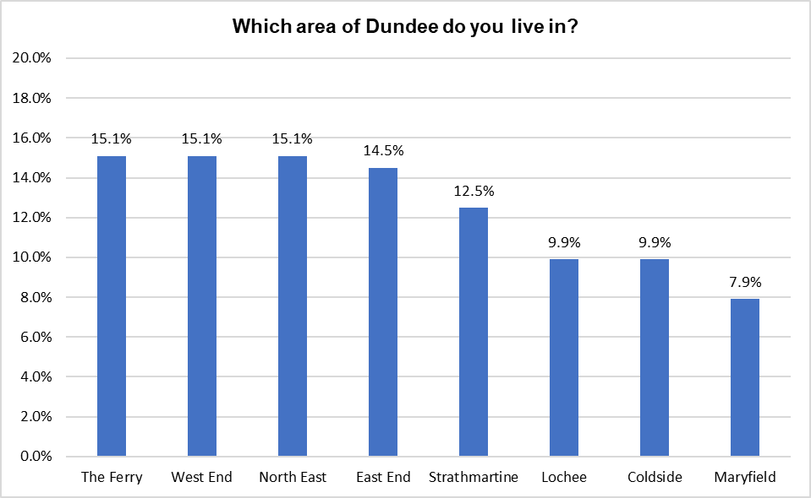

Question 2 - Which age group are you in?

Figure 2: Which age group are you in?
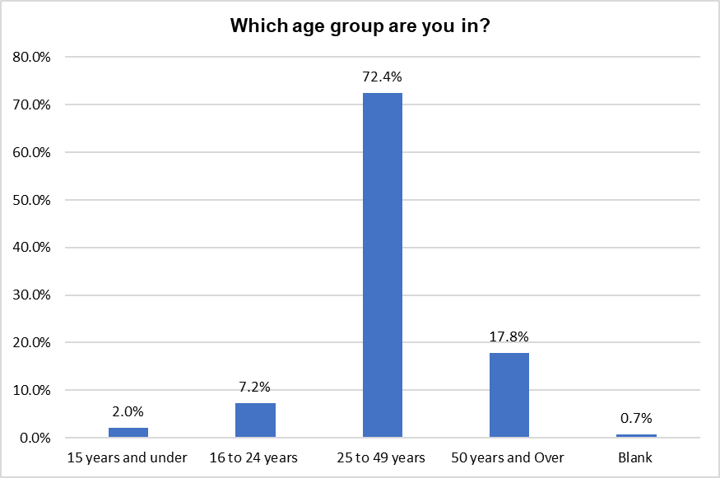

Question 3 - Have you previously made use of the access to free period products in Dundee?

Figure 3: Have you previously made use of the access to free period products in Dundee?
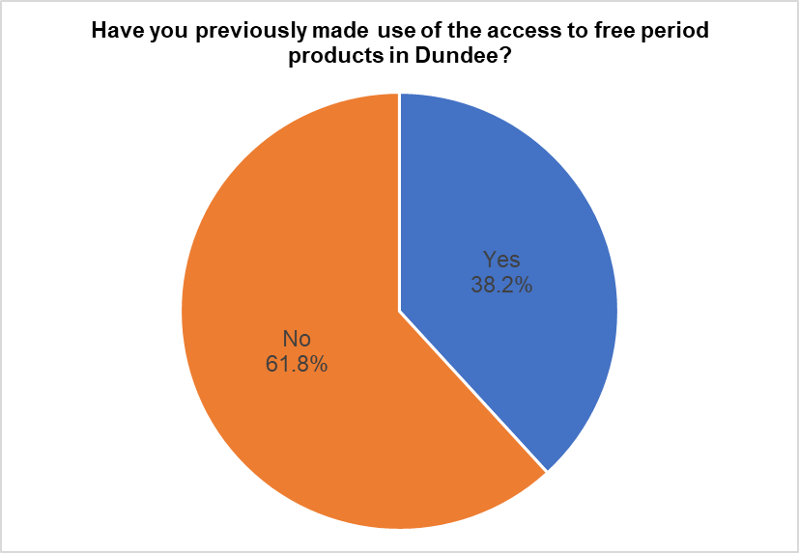

Question 4 - Tell us more about where you accessed these free period products?

Figure 4: Tell us more about where you accessed these free period products?
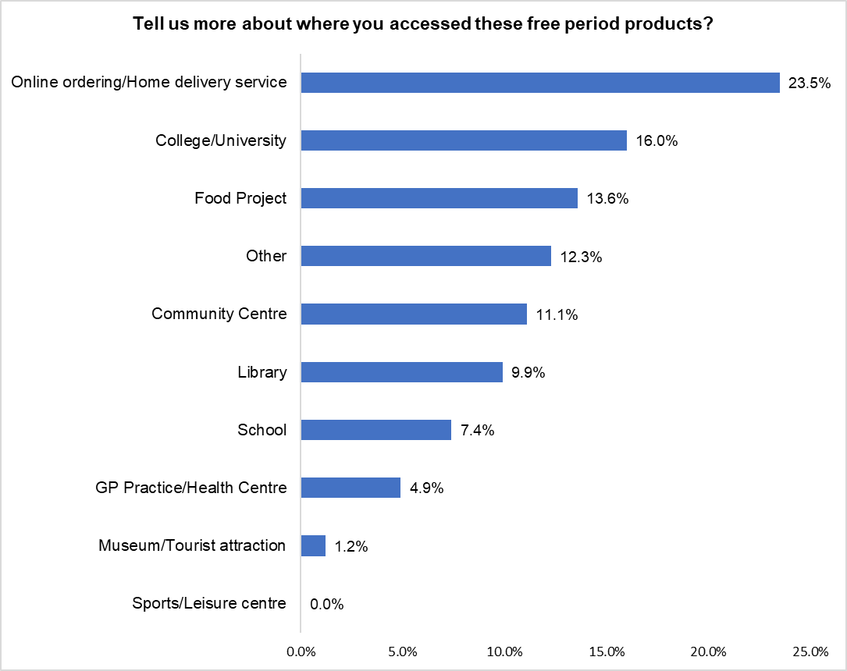
(% of total yes responses: 81)

Responses from those who stated ‘Other’ are displayed in the table below:

Response | Number of Responses
Work | 3
Caird Hall | 2
Ormiston mum and toddler group | 1
Office | 1
Homeless accommodation | 1
Received reusable pack | 1
Health Shop Ninewells | 1
Table 2: Responses from those who stated other

Question 5 - What free period products have you accessed?

Figure 5: What free period products have you accessed?
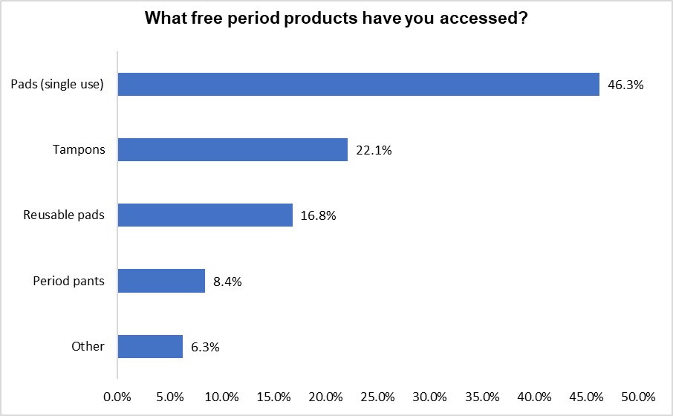
(% of total yes responses: 95)

Responses from those who stated ‘Other’ are displayed in the table below:

Other Product | Number of Responses
Menstrual cup | 5
Table 3: Responses from those who stated Other

Question 6 - Based on your experience of accessing free period products please rate the extent that you felt comfortable?

Figure 6: Based on your experience of accessing free period products, please rate the extent that you felt comfortable?
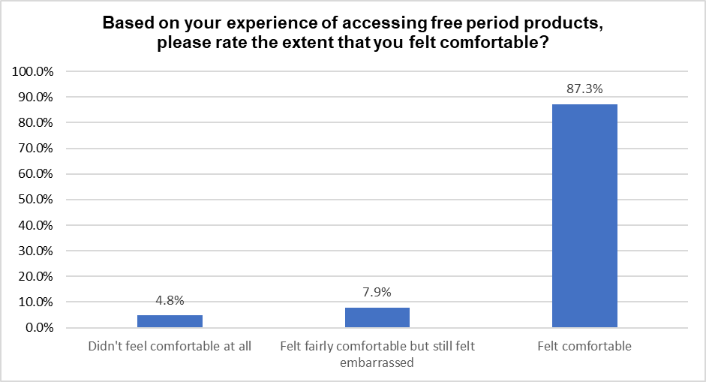
(% of total yes responses: 63)

Examples of some of the comments made in response to this question are shown below:

Comments from those who were not comfortable: “Not accessed as signs saying they have to ask at reception”

Comments from those who were fairly comfortable: “Had to ask at reception”

Comments from those who felt comfortable: “They were in the toilets so easy and discreet to access, didn’t have to ask, products are comfortable and easy to wash”

Question 7 - Who do you/or would you wish to access free period products for?

Figure 7: Who do you/or would you wish to access free period products for?
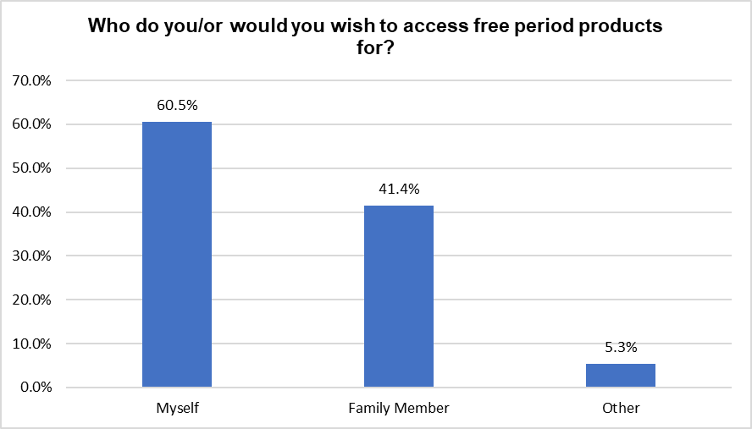

Comments made by those who stated ‘Other’ are displayed in the table below:

Other | Number of Responses
Service Users | 3
Work colleagues | 2
Young people they work with | 1
Patients | 1
Friend | 1
Table 4: Responses from those who stated other

4. Future Provision

Responses to questions relating to future provision are shown below:

Question 8 - Where do you think would be the best place to access free period products?

Figure 8: Where do you think would be the best place to access free period products?
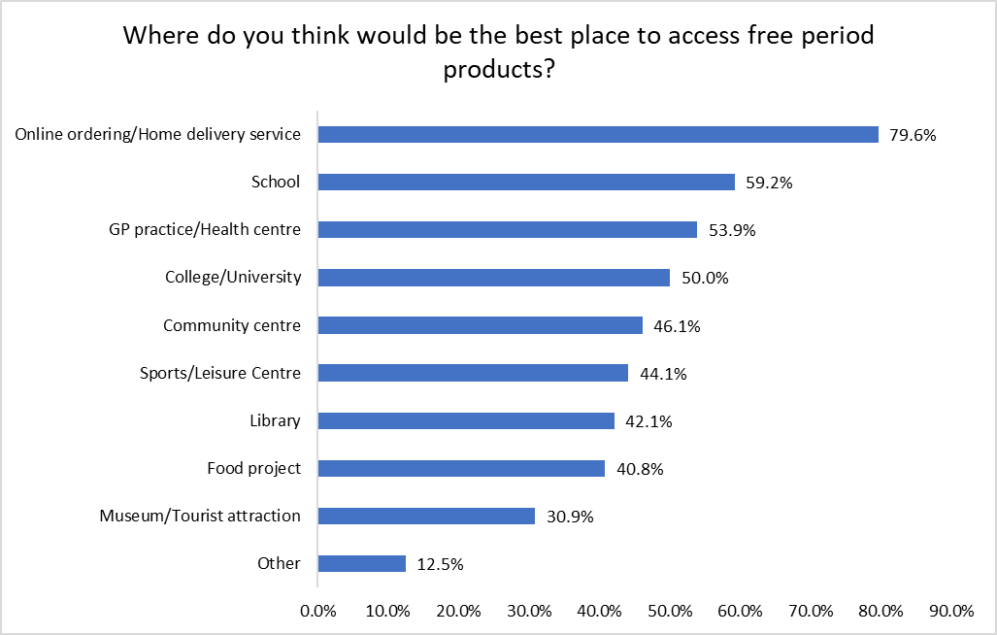

Responses from those who stated ‘Other’ are displayed in the table below:

Other | Number of Responses
Public toilets | 3
Supermarket | 2
Homeless accommodation | 2
Work places | 2
Shopping Centre | 1
Dundee International Women’s Centre | 1
Council offices open to the public | 1
Changing rooms in shops | 1
Pharmacy | 1
Ninewells | 1
All of the above | 1
Job centre | 1
Social work office | 1
Other health services i.e. outpatient / inpatient areas | 1
Table 5: Responses from those who stated Other

Question 9 - Where in venues would you be happy to access free period products?

Figure 9: Where in venues would you be happy to access free period products?
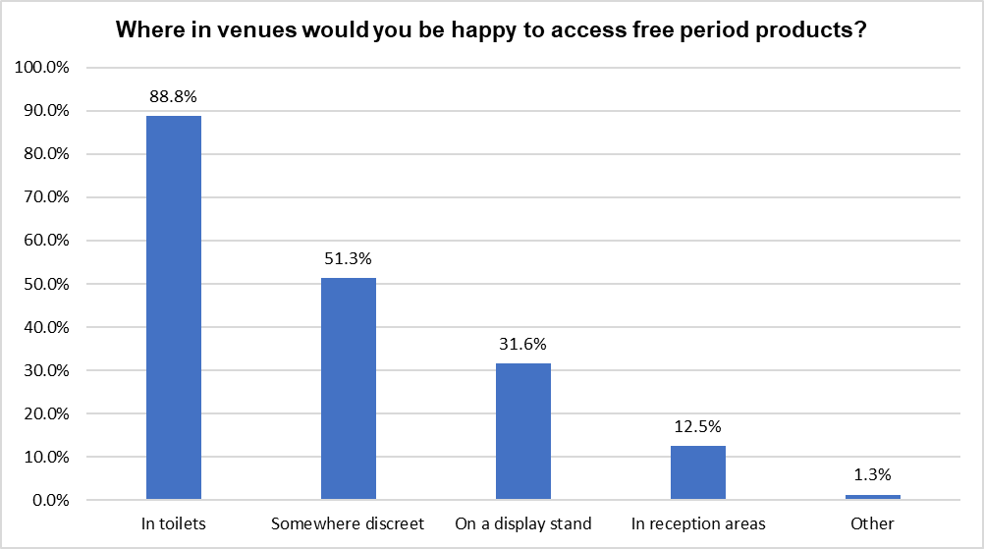

Comments from those who selected ‘Other’ are displayed in the table below:

Other | Number of Responses
Anywhere without having to ask | 1
All of the above | 1
Clear signage is also important | 1
Table 6: Responses from those who stated Other

Question 10 - What free period products do you think should be made available in your community?

Figure 10: What free period products do you think should be made available in your community?
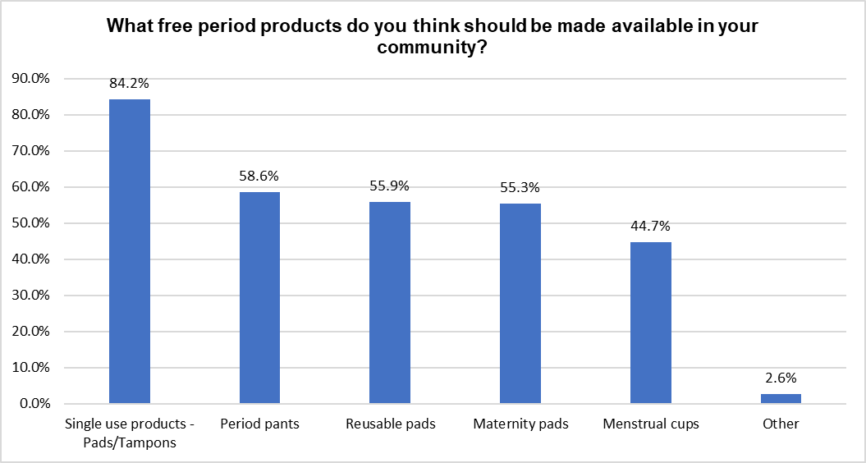

Comments made by respondents who stated ‘Other’ are displayed in the table below:

Other | Number of Responses
All of the above | 3
Incontinence pads | 1
Table 7: Responses made by those who stated Other

Question 11 - What, if anything would stop you from accessing free period products?

Figure 11: What if anything would stop you from accessing free period products?
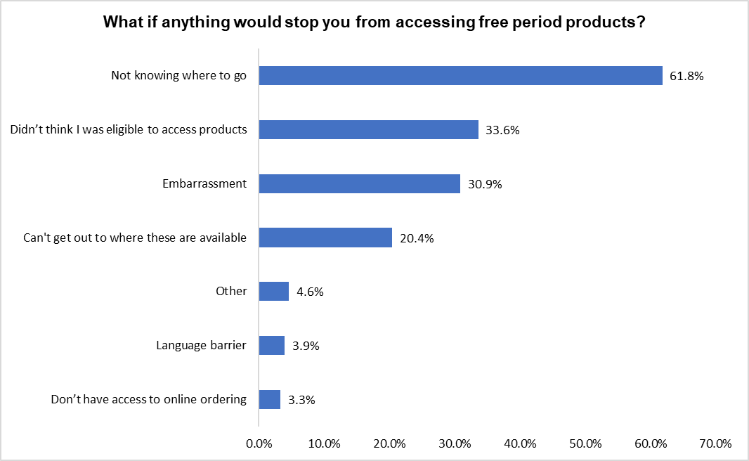

Responses from those who stated ‘Other’ are displayed in the table below:

Other | Number of Responses
Poor quality or lack of sizes (for different flows) of products | 3
Lack of knowledge/awareness schools and colleges | 1
Happy to pay for them | 1
Disagree with products in men’s toilets/available for men | 1
Having to ask for them | 1
Table 8: Responses from those who stated Other

Question 12 - In order for us to provide the best possible service it would be helpful to let us know if you have any particular personal circumstances which would affect the way in which you access free period products and what we could do to help overcome these?

A summary of the key points raised in response to this question are shown below:

- Having health issues was a factor for a number of respondents including physical disabilities meaning it is difficult to leave the home, social anxiety and other mental health issues meant these respondents would rather access online for home delivery.

- Those from BME communities stated that language is barrier in having to ask for products and also awareness of the service in general.

- Those who identified as transgender stated that access in male toilets would be welcome.

- Those on low income stated that not having to travel to access products would be helpful to avoid any associated costs.

Examples of some of the wider comments in response to this question are shown below:

- As someone who struggled with period poverty growing up, access to free period products has been so dignifying for me. I feel so much better knowing that other little girls are no longer going to feel embarrassed or ashamed for not having access to period products when they are at school or at home, and they can get on with their days just like everyone else.

- Strongly support the provision of reusable period products. Think lots of people my age (being used to disposables for a long time) are wary of them so information at the point of receiving the products is important. Could be signs letting people know they can ask a member of staff, leaflets, QR codes linking to online videos/info, etc. Needs to be fun!

- Starter packs in primary schools would be a great option, particularly with reusable options.

- Reusable options available locally would be welcome, felt there are barriers to accessing these at the moment.

- More awareness and communication of the service is needed.

